Eight Years B.C.: Bill Cunningham Exhibit Opens at NY Historical Society
March 14, 2014 8:30 AM
Intrepid blue-smocked street photographer Bill Cunningham turned 85 yesterday, and the New York Historical Society marked the occasion with a press preview of an exhibit of his photographs. We dispatched writer Nancy Lazarus—via bicycle, of course—to take in the architectural riches and fashion history of New York through Cunningham’s lens. The show opens to the public today.

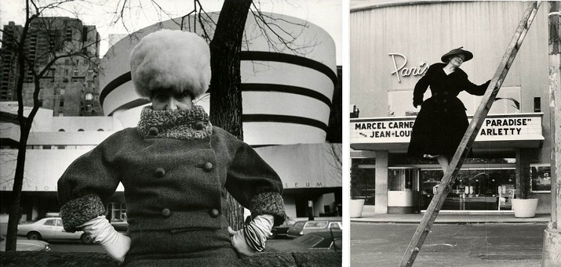
(All photos courtesy New York Historical Society)
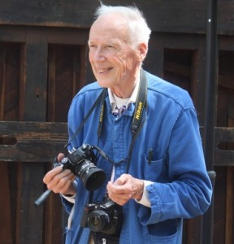
While his images don’t depict biblical times, Bill Cunningham did delve back to the Civil War, Victorian era, and Gilded Age for his eight-year-long project, Facades. From 1968-1976, the New York Times photographer who documented social, architecture, and fashion trends collected over 500 outfits and shot more than 1,800 locations around New York City. Editta Sherman, his friend, neighbor and fellow photographer, served as project collaborator and frequent subject.

Cunningham donated 88 black-and-white images from his photo essay to the New York Historical Society in 1976, and 80 gelatin silver prints and enlarged images are on display through June 15. Valerie Paley, NYHS historian and vice president for scholarly programs, curated the exhibit, and she said assistant curator Lilly Tuttle, found the photos in the museum’s archives. “We have so many undiscovered treasures, and we’re delighted to rediscover them,” said Paley.

Although Cunningham wasn’t on hand for yesterday’s preview, Paley said he was enthusiastic about the exhibit and had pitched in to locate details of specific photos. Many of his quotes accompany the exhibit highlights. The display is arranged by historic era, and additional photos in the collection are projected onto the walls of the museum’s side entrance rotunda.
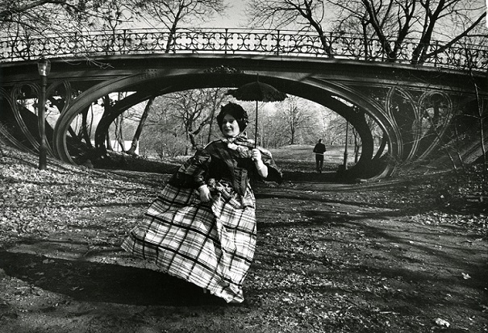
Cunningham reported that he undertook Facades “just for the fun of it.” He used the camera as his notebook, and he believed that “the fashion show has always been on the street”. In a series of photos, Sherman, a.k.a. “the duchess of Carnegie Hall,” theatrically posed outside historic NYC buildings while dressed in period costumes. The pair often worked on weekends to complete the project.
Cunningham scouted locations on his bicycle, preferring to shoot at landmarks like Grand Central Terminal, Delmonico’s restaurant, and the Paris Theatre. He sourced vintage clothing items at thrift shops, street fairs and auctions, such as velvet frock coats, breeches, muslin gowns, white gloves, and parasols.
Since he was a former milliner, flamboyant hats were one of Cunningham’s specialties. He was born around the Great Depression and lived through two world wars as well as New York’s financial crisis. As he noted, he liked to use amusing hats “to lift spirits.”
What’s striking about Facades is that it focuses on looking back. But the images have a timeless feel, and there’s a reason for that. Since many aspects of the project involve familiar themes, like fashions of the street, graffiti, working weekends, and urban bike riding, one is left with an impression that’s more recent.

Writer Nancy Lazarus is a frequent contributor to UnBeige.

